

## PAK–ARAB REFINERY LTD.

## TO WHOM IT MAY CONCERN

It is certify that Mr. <Name> S/o <fname> has worked in Pak Arab Refinery Ltd. Mehmood Kot Distt. Muzaffargarh as a <Designation> through contractors Al-Mubeen & Company in project work from <From2> to <To2>.

He is hard worker, honest and obedient to his seniors.

# We wish him success in Future life.

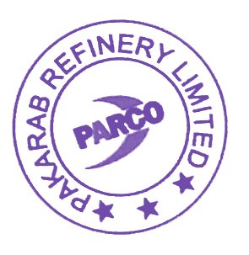Yours faithfully,

For PAK-ARAB REFINERY LIMITED



Ahsan Kamal

Manager

Human Resource Development